(these notes and some charts are summarised from
Hodgson, J 1997 Soil Survey field handbook. Soil Survey Technical monograph 5.
Reproduced with permission of NSRI, Cranfield University. © Cranfield University [June 2012]. No part of this publication may be reproduced without the express written permission of Cranfield University.)

For each layer (‘horizon’) record the following:

Depth range (e.g. 0-25cm) | Always quoted a depth below the surface ….
Main colour | See Munsell chart – hold a small piece of soil behind the chart and record the colour. Ideally this should be done in moist conditions.
Mottles colour / size abundance | If there are ‘mottles’ – patchy coloration due to the chemical effects of wetness / gleying, record  colour as above  abundance from chart 1  size:  very fine < 2mm  medium 2-15mm  coarse > 15mm
Texture | Feel the texture - chart 3
Structure /size /shape | structure from chart 5  size from chart 2
Stones - content / type / shape | shape from chart 4  abundance  very slightly stony 1-5%  slightly stony 6-15%  moderately stony 16-35%  very stony >36%  size  small <2cm  medium 2-6cm  large 6-20cm  very large >20cm
Roots / size / shape / abundance | Size e.g. long, thick  Shape e.g. woody, fibrous
Boundary sharpness | Sharp – changes over 0.5cm  Abrupt – changes over 0.5-2cm  Clear – changes over 2-5cm  Gradual – changes over 5-15cm  Diffuse - changes over >13cm
Notes / horizon name
Chart 1 :Abundance:

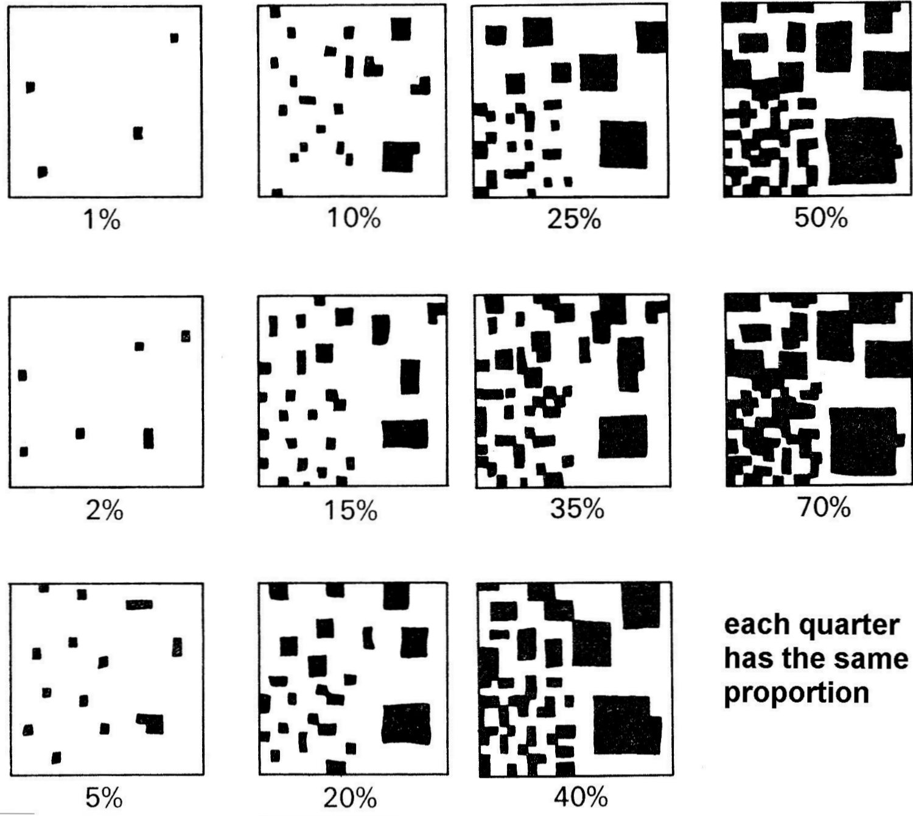

Chart 2 : Ped Sizes:

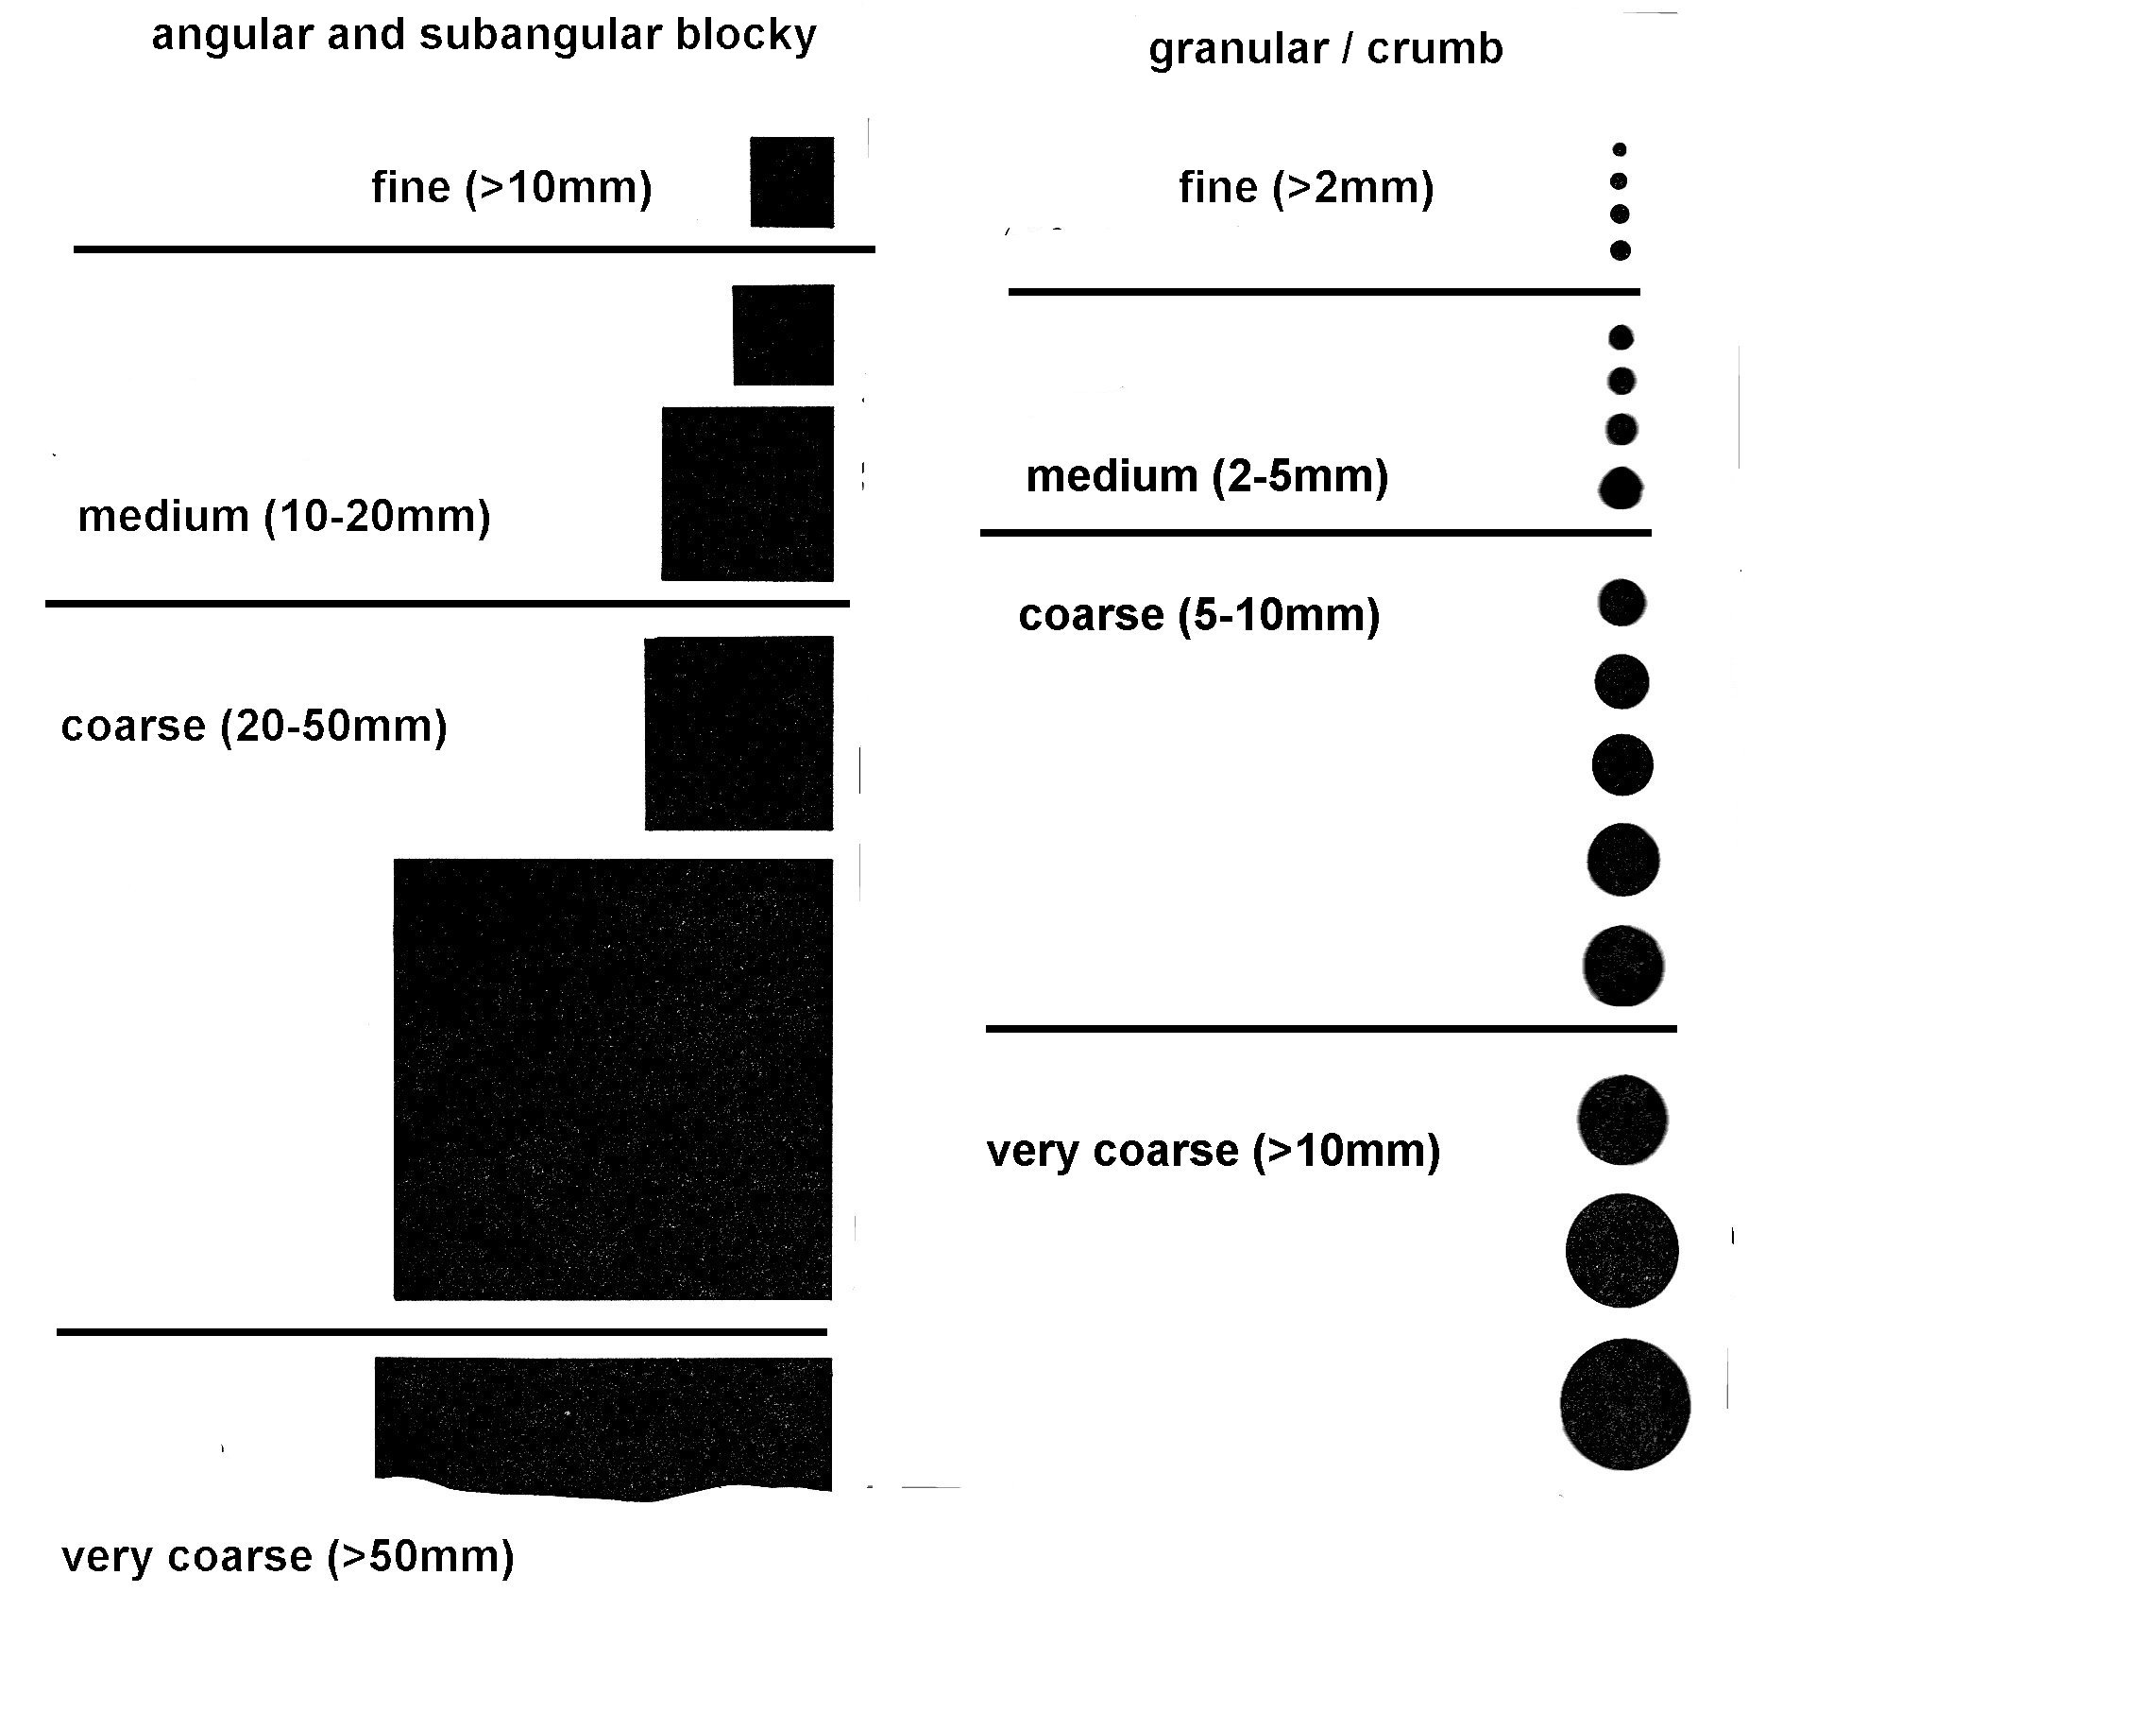
Chart 3 Soil Texture – by hand
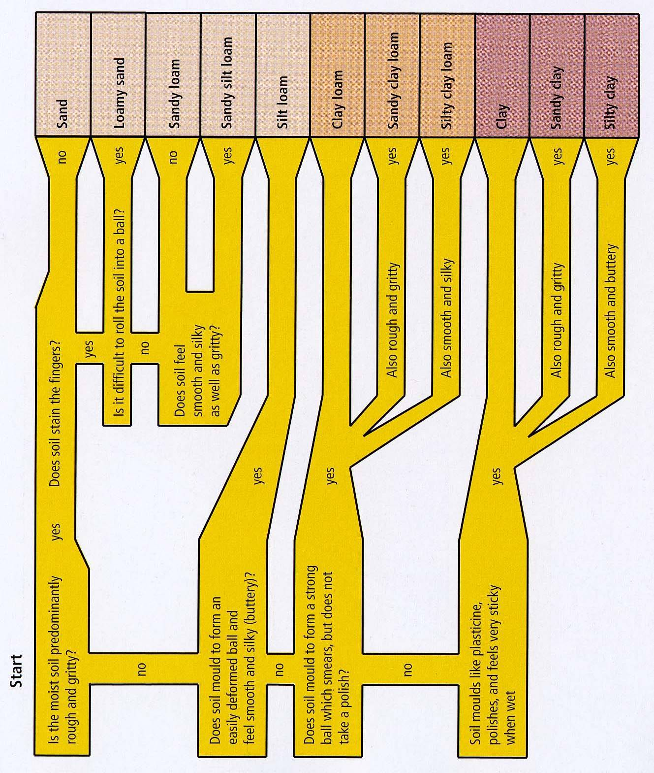

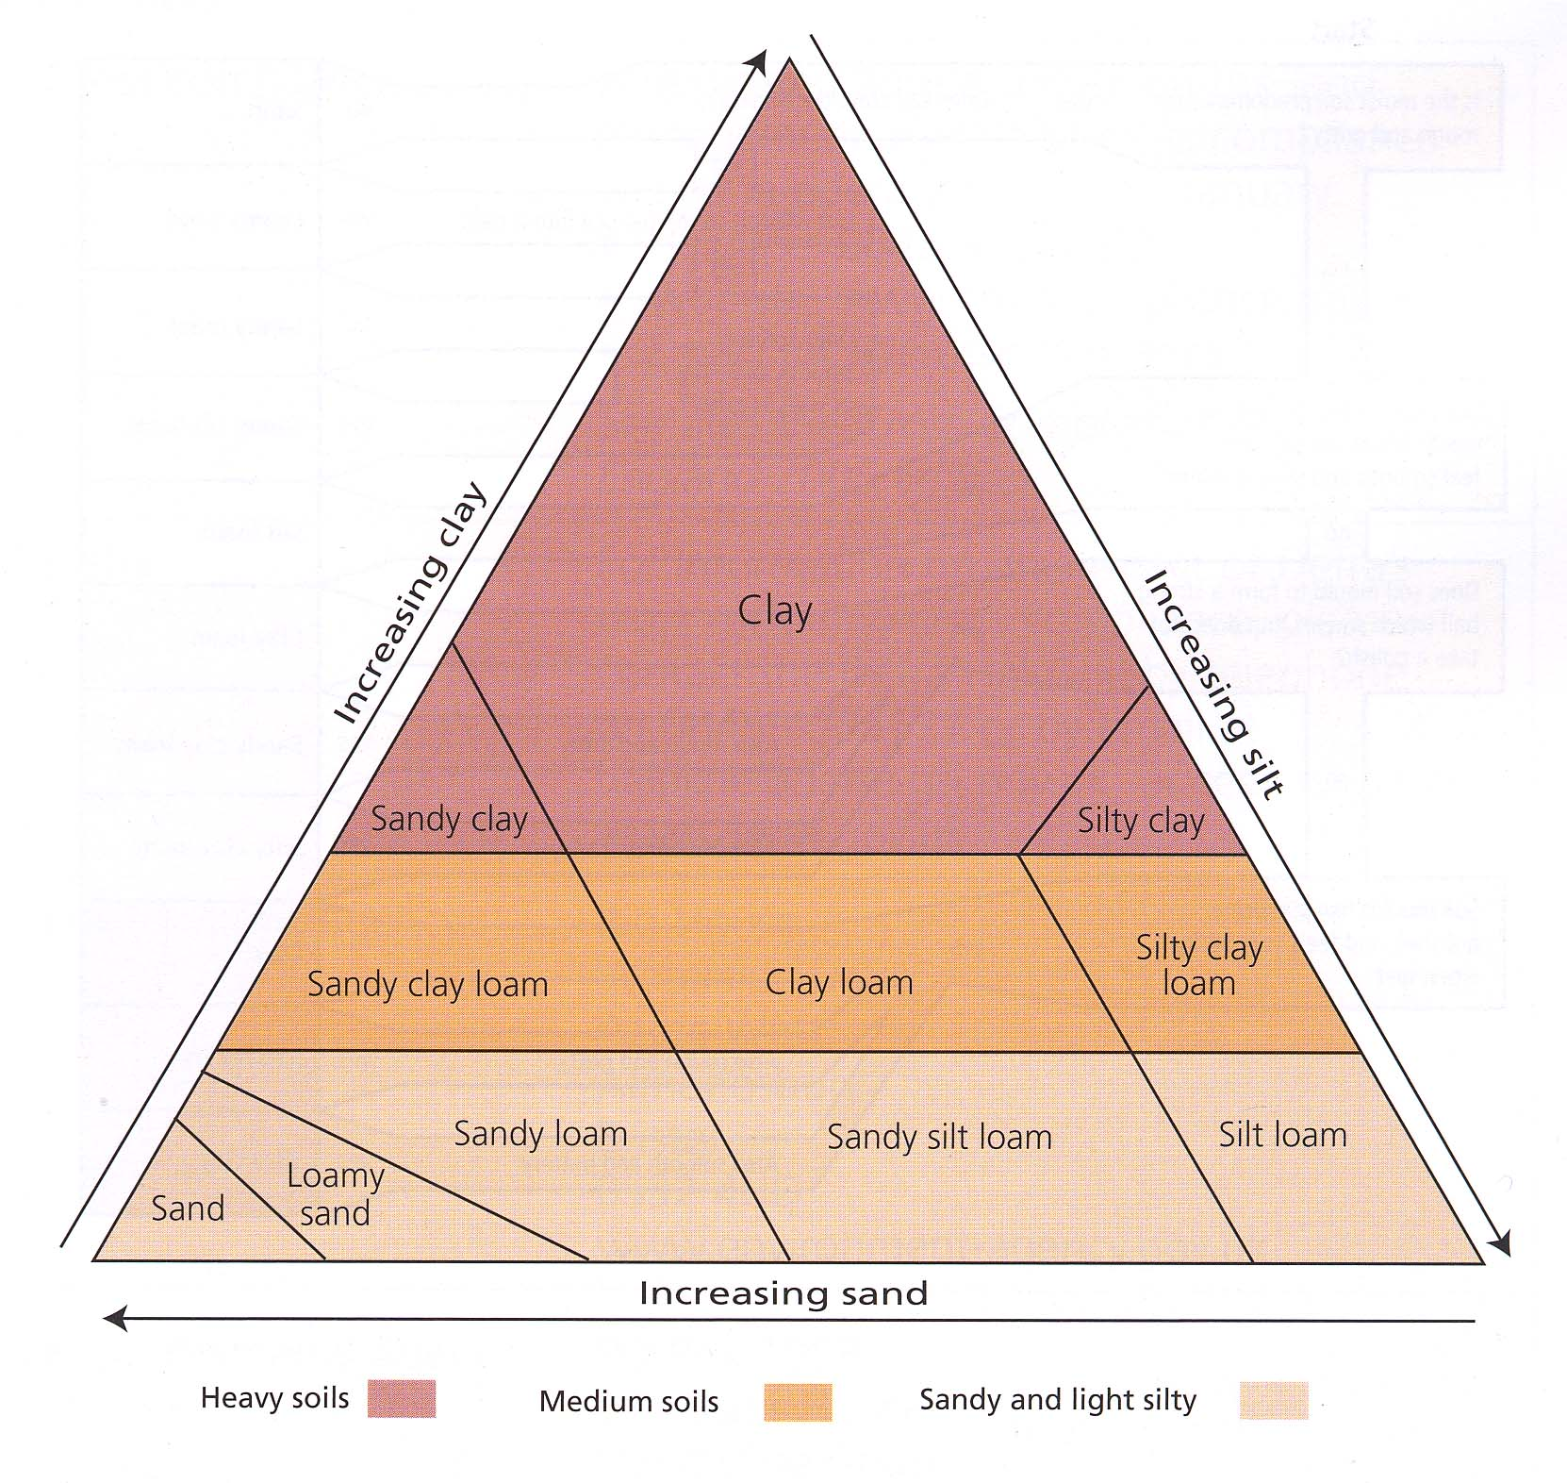
Chart 4 : Stone shapes

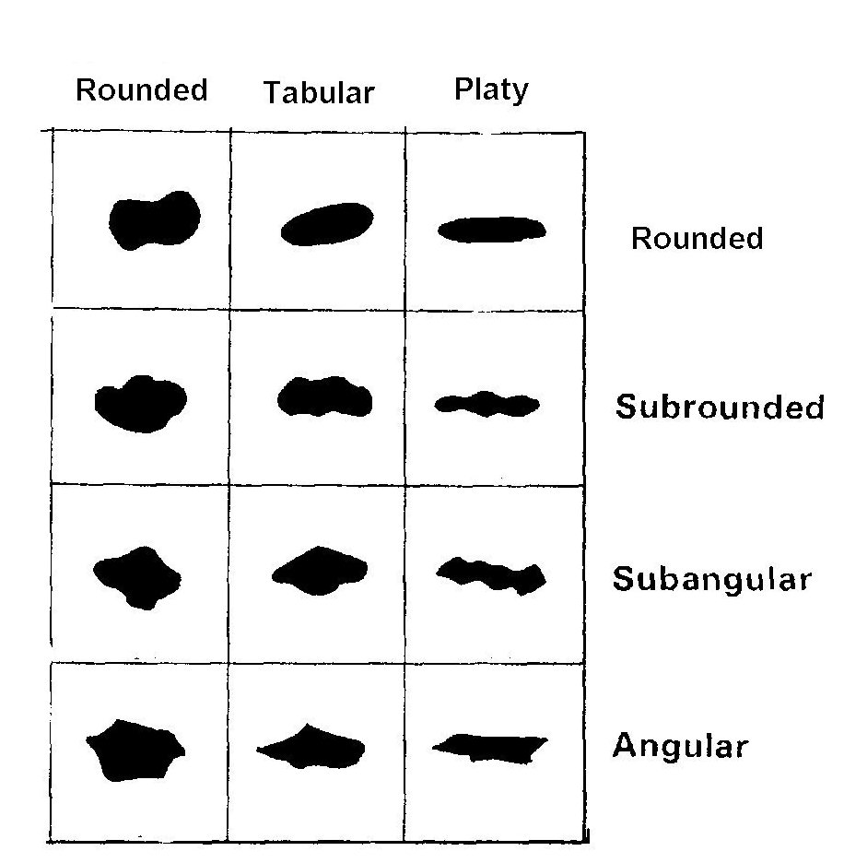

Chart 5 Structure
