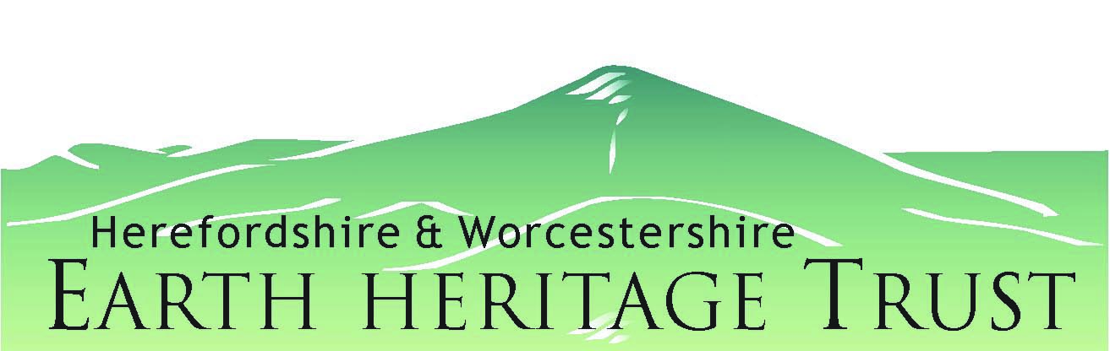
Borsetshire RIGS Group

Local Geological Sites [RIGS]

Condition Monitoring Form - for NI 197 reporting. Logo & contact address

1. Site Information
Site Name & RIGS ID
Site Type |  |  |  |  | Grid Reference
Date of Visit |  |  |  |  | Local Authority
Surveyor |  |  |  |  | Landowner
1:50,000 BGS Sheet no. |  |  |  |  | 1:25,000 OS Sheet no.
RIGS designation | Scientific |  |  | Educational |  |  | Aesthetic |  |  | Historical
Interest Feature(s):

Previous management and dates (if any)

2. Primary Factors
Bedrock feature | Is (are) the feature(s) exposed? |  |  |  | If No, can it (they) practically be re-exposed?
Bedrock feature | Is (are) the feature(s) being affected by the following factors?
Bedrock feature | Factor |  | Y/N | Comments
Bedrock feature | Vegetation
Bedrock feature | Scree/Mass Movement
Bedrock feature | Flooding
Bedrock feature | Dumping/Landfill
Bedrock feature | Quarrying/Engineering Works
Bedrock feature | Development (housing/industrial)
Bedrock feature | Others (please define) -
Superficial deposit feature | Is (are) the feature(s) exposed? |  |  |  | If No, can it (they) practically be re-exposed?
Superficial deposit feature | Is (are) the feature(s) being affected by the following factors?
Superficial deposit feature | Vegetation (Trees or crop planting)
Superficial deposit feature | Agricultural practices (deep ploughing)
Superficial deposit feature | Quarrying/Engineering Works
Superficial deposit feature | Development (housing/industrial)
Superficial deposit feature | Others (please define) -
Geomorphology feature | Is (are) the geomorphological feature(s) being allowed to evolve naturally?
Geomorphology feature | Is (are) the feature(s) being affected by the following factors?
Geomorphology feature | Vegetation
Geomorphology feature | Sea Defences
Geomorphology feature | River Management
Geomorphology feature | Ground Stabilisation (slopes/sand dunes)
Geomorphology feature | Water level change
Geomorphology feature | Development (housing/industrial)
Geomorphology feature | Others (please define) -

3. Secondary Factors
Factors that do not directly affect the feature(s) but may need to be managed in order for feature(s) to maintain a desirable condition
 | Factor | Y/N | Comments
Site access | Are any of the following causing difficulties in accessing the site?
Site access | Physical obstacles
Site access | Landowner permissions
Site access | Protected species/habitats
Site access | Other (please define)
Furniture | Are any of the following in an undesirable condition?
Furniture | Interpretation Boards
Furniture | Benches/Fences/Gates
Furniture | Earthworks
Furniture | Other (please define)
Other features | Are there any other features of interest that should be considered?
Other features | Biodiversity
Other features | Historic Environment
Other features | Other (please define)

Site Status
Overall, is the site in a desirable condition for use(s) of the feature(s) identified? | Yes / No / Uncertain
 | Status:
If Yes - what management is required (if any) for the feature(s) to maintain a desirable condition:

For the above, is the management: Being undertaken / Going to be undertaken / Not going to be undertaken / Not possible
If Uncertain or No - what management is required for the feature(s) to reach and maintain a desirable condition:

For the above, is the management: Being undertaken / Going to be undertaken / Not going to be undertaken / Not possible
Are there any secondary factors that need further management? | Yes / No / Not applicable
Suggested management in order for the feature(s) to reach/maintain a desirable condition:

Photos – Eight figure grid references, landmark, direction of photo (bearing)

